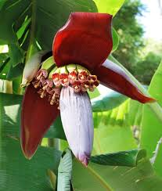
Banana flower chutney

Banana flowers are called banana hearts for a reason!! They are not only pretty but also having a host of health benefits too. Intake of this flower reduces blood sugar level and also increases the total hemoglobin level in the body. Banana flowers contain various vitamins like Vitamin A, C and E. They also contain Potassium and Fibres. So include it in your menu instead of throwing away as a waste..
Ingredients: Banana flower cut into pieces-1/2 cup
Coconut gratings -1 cup
Green chili-3
Curds ½ cup
Salt to taste
Water, lemon juice
Oil, red chilly, and mustard for seasoning.

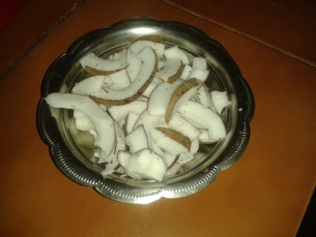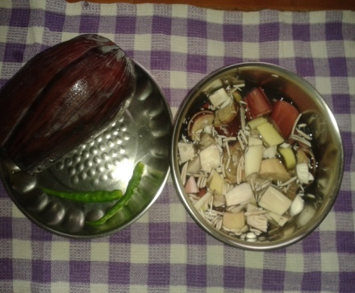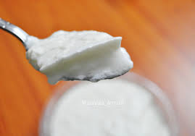
Peel the outer 4-5 layers of the banana flower and cut into small pieces and immerse in sufficient water by adding few drops of lemon juice to retain its color and also remove its bitterness. Keep aside for 15 minutes. Remove the water and rinse 2-3 times thoroughly. Take it in a bowl, add green chilly, and cook till soft by adding sufficient water. Let it to cool down completely.

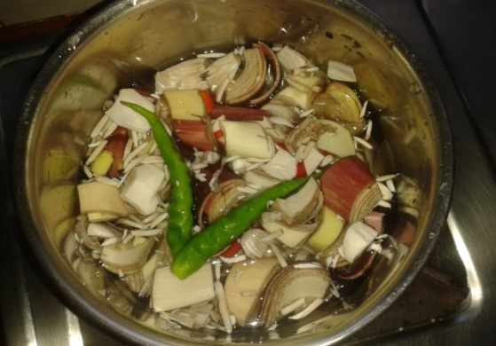
Grind this cooked banana flower nicely by adding grated coconut, salt to taste and curds. Season it by adding oil, red chilly and mustard seeds .It is a spicy, lip smacking side-dish for rice,dosa and chapatti.

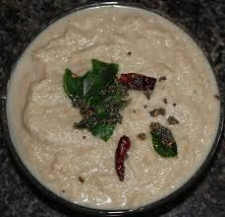
Note- Always use fresh banana blossoms. Peel the hard outer layer of the flower, better to peel till you get the white layers of the flower.
Yoghurt can be replaced by thick buttermilk. If necessary water can be used along with curds while grinding the chutney.

OM SHANTI.

