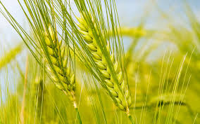

Dosa is a kind of breakfast item which all love to eat. Wheat dosa is one of such item which everyone can try to prepare easily when we feel to have something other than chapathi. It is a variety one for the wheat lovers.
Ingredients—Wheat grain -1 cup
Coconut gratings -¼ cup (optional)
Salt to taste. Oil or ghee -2 tbsp
Method---Wash 1 cup of the Whole wheat to 2 to 3 times changing the water each time. (Here we need not soak the wheat to avoid the stickiness of dosa) Grind the wheat adding water little by little along with coconut gratings (optional). Batter should not be too fine (We should feel the texture of batter like a semolina or sooji) .Add salt and mix well.
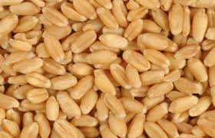
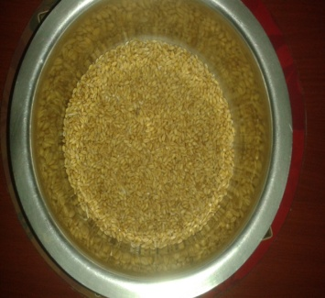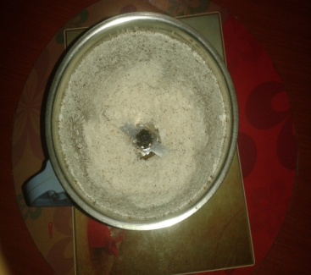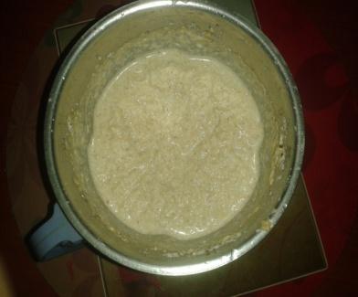
Heat a dosa skillet on a medium heat. Take one ladle full of dosa batter and pour at the center of the skillet. At the back of the ladle spread the batter in circular motion from the center, widening towards the edge as thin as possible. Drizzle 1 tsp of oil/ghee on the top of the dosa and cook till it turns into light brown in color in a medium heat. When done, remove from the skillet, by using flat spatula. Repeat the same process for the rest of the batter. Serve the dosa with chutney, sambar of your choice!!
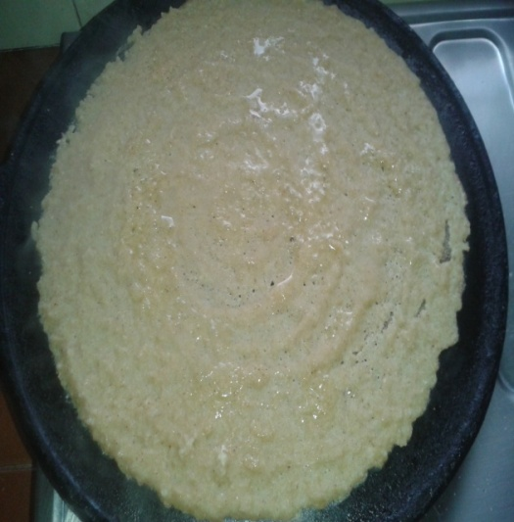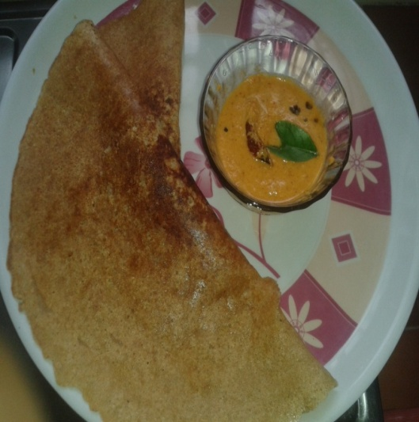
Note: We can add finely chopped coriander leaves, curry leaves, green chilli, and small piece of ginger to the dosa batter to get nice aroma. Coconut lovers can add coconut gratings which give nice aroma to the dosa it can be avoided if you don’t like it.

OM SHANTI

