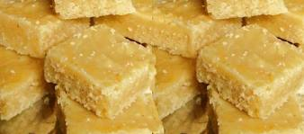

Festival season is a tool to bring exuberance and enthusiasm. In golden age, there used to be festival everyday of the year. It gives unique opportunity to gather, to share and to care with family, friends, relatives and community.Toli is the integral part of festival. It symbolises sweetness in thoughts, words, and relation. Hence once in a while sweet can be prepared and shared to bring sweet memories of those “Glorious Days”!!!!!!

Ingredients:1 cup besan,1cup shredded coconut,3 cups of sugar,1 cup milk, 1 cup ghee.( Dry fruits, cocoa powder -optional)
Method: Take besan in a bowl and add 1 cup of milk and make a paste without any lumps and keep it aside. Take a kadai, pour 3 cups of sugar add 1 tbsp of water, just to wet the sugar and stir in a high flame for 2-4 minutes .Now add besan paste, stir well and bring to boil. Add shredded coconut and ghee. Keep on stirring till you feel hard to stir and ghee separates and leaves the side.

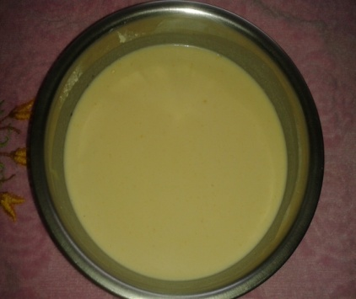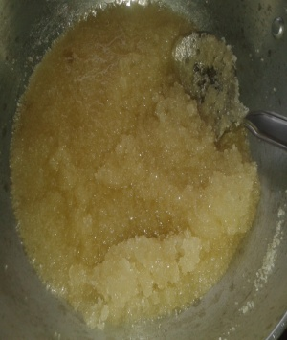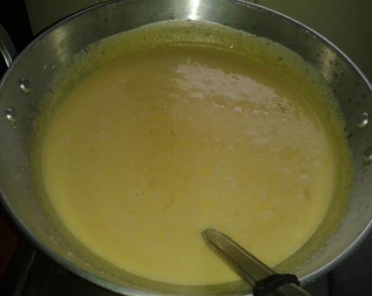

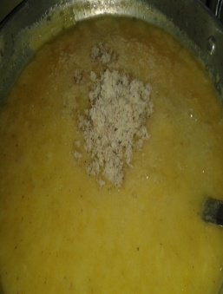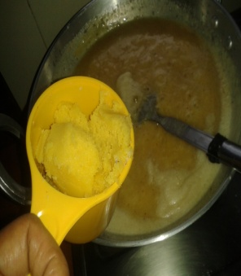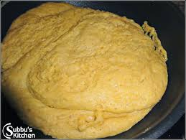
You can add dry fruits and cocoa powder at this moment.( Normally “seven cups’ needs only these seven cups of ingredients as its name itself mentions it ! ).Pour to a tray and cut into pieces of your choice when it cools down to room temperature.
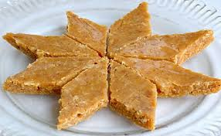
Om shanti

